PUB 741

Bitumen/Polyurethane Based, One Component, Liquid, Waterproofing Material

PRODUCT DESCRIPTION
PUB 741, is a single component, bitumen
/ polyurethane based waterproofing coating that bridges cracks, curing with air humidity. It is liquid. Adheres perfectly to different surfaces, creating a durable and elastic film. Has high mechanical and chemical resistance and resistant to tensile, tear and abrasion with its flexible structure.
It is based on pure elastomeric hydrophobic polyurethane resin and is extended with chemically polymerised virgin bitumen.

APPLICATION AREAS
PUB 741 is used for the protection and waterproofing of the following surfaces that are not exposed to direct sunlight;

- Terrace, roof and rain gutters,
- Verandas and balconies,
- Construction bases and flores,
- Retaining walls,
- Wet surface under tile,
- Light roofing made of metal or fibers from materials,
- Bitumen, PVC, EPDM based membranes,
- It is used with suitable primers on concrete, wood and metal surfaces.

PROPERTIES
- Suitable for cold application and can be easily applied with a roller, trowel, brush or airless spray gun.
- Displays high crack bridging property.
- No additional applicable.
- Resistance to ponding water and frost.
- It maintains physical properties at -30ºC
/+90ºC.
- Water vapor permeable and allows the surfaces to breathe.
- Excellent adherence properties.
- Should not be exposed to UV.
- Shows effective resistance to chemicals.
- Does not contain toxic substances after curing.
- Based on pure elastomeric hydrophobic polyurethane resin and is extended with chemically polymerised virgin bitumen.

PRODUCT INFORMATIONS PACKAGING
- 25 Kgs Pail
- 12 Kgs Pail

COLOR
- Black

SHELF LIFE
- The shelf life is 12 months if the specified storage conditions are followed in its original unopened packaging.

STORAGE CONDITIONS
- Store in a dry and cool environment (between +15ºC / + 25ºC)
- It should be protected from water, frost, heat, ignition, direct sunlight and adverse weather conditions
- The date of manufacture is on the label.
- Even opened packages are tightly closed, the inside of the product will be curing quickly so that the opened cans should be consumed in short time.

CONSUMPTION
- As Two layer 1,500 – 2,000 kg/m² min.

Consumption may vary depending on surface roughness, ambient and surface temperature and application method.

PUB 741
Bitumen/Polyurethane Based, One Component, Liquid, Waterproofing Material

APPLICATION INSTRUCTIONS SURFACE PREPARATIONS
Application surfaces should be dry and clean. Concrete and plaster residues should be mechanically; Oil, grease, fuel and paraffin wastes should be cleaned using chemical solvents. Damages and cracks must be repaired with products that are available.
PUB 741 should be applied priming with a suitable primer based on epoxy or polyurethane after depending on the surface condition.

- Hardness of application concrete (R28 = 15 Mpa)
- Temperature: 5-35 °C
- Relative humidity of air: <85%

PRIMING
Highly absorbent surfaces such as concrete, cement screed or wood; Before priming, the primer should be applied after the film is saturated with PU primer.

It is of great importance for a correct application that the surface is smooth and saturated with primer. If the surface is not cleaned and primed properly, it can lead to the removal of the applied product from the surface, and the formation of problems such as bubbles, craters, pinholes etc. on the surface.

PREPERATION of MATERIAL
  - PUB 741 is a single component and ready to use.
  - Before applying the product, stir for 2-3 minutes with a suitable mixer at a speed of 300 RPM.
  - The packages should kept at room temperature for 24 hours are opened and mixed until homogenous consistency. Mixing should be done with low speed mixer and appropriate mixer tip.

APPLICATION
PUB 741 is applied in 2 coats with thin comb trowel, airless spraying machines, brush or roller.
- Do not wait more than 24 hours between coats.
- The primer surface should be sanded before the application of new coats exceeding 24 hours.
- If the application is intended to be applied by spraying method, the material should be applied after the thinning of MİM Polyurethane Thinner.
- The packages kept at room temperature for 24 hours are opened and mixed until homogenous consistency. Mixing should be done with low speed mixer and appropriate mixer tip.

PUB 741
Bitumen/Polyurethane Based, One Component, Liquid, Waterproofing Material

- PUB 741, offers practical application which can be applied without needing thinning in ready-to- use packages.
- PUB 741 spreads homogeneously by making consumption control on the primed surfaces with the help of thin comb trowel, short-hair roller brush or airless spray gun.
- The layer must be protected against water and rain, external influences and mechanical stress until it is dry.
- If the second coat is applied, it should be waited between the coats (approximately 6-24 hours). It should be taken into consideration that waiting time can be shortened in hot weather and it can be extended in cold weather.

SAFETY
- Wear gloves, goggles and protective clothing.
- In case of contact with skin, wash with soap and water.
Users should refer to the latest Material Safety Data Sheets, including physical, ecological, toxicological, and other safety-related data for information or advice on the safe transport, storage, disposal of chemical products.

CLEANING TOOLS
  - Cleaning of the tools should be done with soapy water before curing.
  - After curing cleaning should be done with thinner.

LIMITATIONS
- In closed areas due to long-term solvent odor and/or vendors the environment should be well ventilated.
- The surface temperature should be
+5ºC. The mixture of the material should be made with a special mixing device and tip which does not exceed 300- 400 RPM and it should not be mixed with high speed drill.
- In cold weather, packagings must be stored at a minimum temperature of
+15 ºC for at least 24 hours prior to application.
- Water vapor pressure should not be observed on the negative side. In such a case, special insulation must be applied before application.
- After the application, the surface must be protected against water, rain, dew, snow, hail etc. until it is dry.
- Full mechanical and chemical strength will occur in 7 days should be considered.
- Contains solvent, flammable.
- Do not contact with open flames and do not smoke during application.
- Do not swallow, do not use empty packages for storing foodstuffs and do not throw them into fire.
- For professional use only, keep out of the reach of children.

PUB 741
Bitumen/Polyurethane Based, One Component, Liquid, Waterproofing Material

DECLERATION
The information contained herein and in particular the application and end-use recommendations are provided in good faith, based on our current knowledge and experience, when properly stored, prepared and applied. The document, not being able to cover all possible scenarios or imply product suitability for every case of application.
Products, application surfaces and application areas are quite diverse in practice. Therefore, when using our products, be sure to apply the right product in the right conditions and in the right place, and strictly follow the information and instructions given by our company regarding commercial convenience and/or suitability for a particular purpose. Otherwise, our MAROF TEKNIK or MAROF YAPI is not responsible for damages that may occur.
The user of the product (user) must test the suitability of the product for the application and purpose for which it intends to use the product. We reserve the right to change the specifications of our products. Property rights of third parties should be observed. Upon acceptance of all orders, our current terms of sale and shipping shall prevail.
Users should always consider the latest edition of the Product Data Sheet (TDS), which we can obtain from our company or our website, by contacting our company for the relevant product.

TORTOISE® TORPUR BPU L
TECHNICHAL DATA
Bitumen/Polyurethane Based, One Component, Liquid, Waterproofing Material

PROPERTIES (23ºC & %50 RH) | UNIT | METHOD | SPECIFICATIONS
Viscosity (BROOKFIELD) | cP/  20 rpm | ASTM D2196-86 / TS 5833 / EN ISO 3219 | 2000-4000
Density (Specific weight) | gr/cm3 | ASTM D1475 / DIN 53217 / ISO 2811 | 1.30 ± 0,05
Solids Content by Weight | % | ASTM D2369 | 80-85
Flash point | oC | ASTM D93 | >30
Touch (Tack free) time | Hour | - | 2-3
Full cure | Day |  | 5
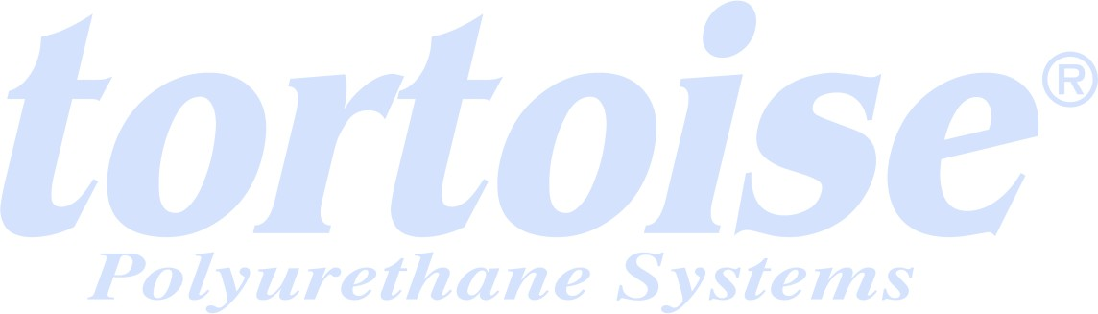  Recoat time | Hour | - | 6-24
Hardness (7 days) | Shore A | ASTM D2240 / DIN 53505 / ISO 868 | 50-60
Tensile strength (7 days) | N/mm2 | ASTM D412 | > 3
% Elongation | % | ASTM D412 / EN-ISO-527- 3 | > 400
Adhesion to concrete | MPa | ASTM D4541 | >2
Volatile Organic Compound (VOC) | g/L | ASTM D3960 | 100-140
Shelf life | month | - | 12

